Ideation Phase
Empathize & Discover
Date | 4 March 2026
Team ID | SWTID-2026-8059
Project Name | Automating Data Import and Relationship Mapping Using Import Sets & Dot Walking
Maximum Marks | 4 Marks

Empathy Map Canvas:
An empathy map is a simple visual tool used to understand the user's behaviors, thoughts, and feelings while interacting with a system.
The benefits include clear insight into user behavior, reduced errors, improved workflow, better decision-making, and increased user satisfaction, making processes and systems more effective and aligned with actual user needs.
EXAMPLE: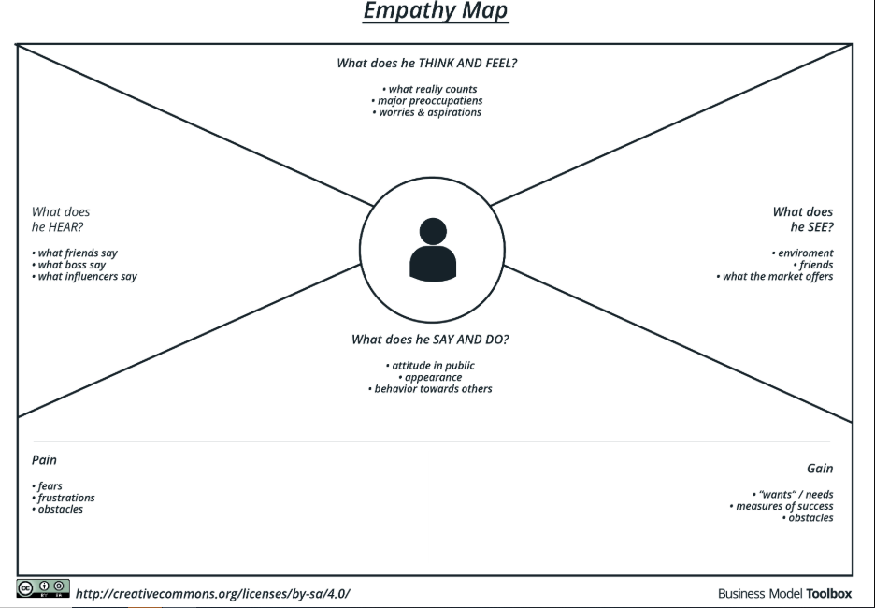
Reference: https://www.mural.co/templates/empathy-map-canvas

